**Appendix B**

This Appendix encloses the description of the plant available water (PAW) or total available water (TAW), which represents the maximum amount of water storage in the root zone that a plant can extract (Figure A1). This parameter depends mainly on three inflow parameters (e.g., Irrigation - $I$, Precipitation - $P$, Capillary rise - $CR$) and three outflow parameters (e.g., Runoff - $RO$, Deep percolation – $DP$, Evapotranspiration - $ET_{c}$,) which relationship is called the soil water balance and relates to the water depletion/accumulation in the soil. Then to support a proper water balance in root zone the following relation must be meet:

|  |  |
| --- | --- |
|  | [] |

Figure B1: Water balance in the root zone. Adapted from Allen et al. (2006).

Water balance in the root zone. Adapted from Allen et al. (2006).

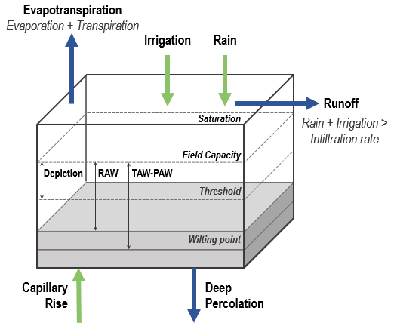

The irrigation represents a decision-maker control factor supported by the farmer and water availabilities, the temporal precipitation is the amount of rainfall in the season, and the capillary rise represents the amount of water transported upward form the water table (i.e., is the depth to which the soil is saturated) to the root zone (Allen et al., 2006). On the other hand, the runoff is the water loss in the soil when the frequency of water (i.e., rain and irrigation) exceeds the soil water infiltration rate (Critchley & Siegert, 1991), the deep percolation represent the soil water loss when infiltrated water exceeds the field capacity content (Bethune et al., 2008), and the evapotranspiration represents the water loss by plant transpiration and water soil evaporation (Allen et al., 2006). Therefore, the water balance in the root zone varies on time considering the relation between the inflow factors and the outflow factors. That relation supports calculating the water depletion in the soil and allows obtaining the amount of water required to restore moisture conditions regarding decision-makers considerations.

* + 1. **Irrigation**

It represents the amount of water released in the field considering the irrigation system (e.g., drip irrigation or sprinkler irrigation), and the water irrigation strategy relating the water application timing (i.e., provide water to avoid critical depletion, yield reduction, or decision-makers define intervals) and the amount of water used (i.e., refill soil to field capacity or to fill until specific application depth).

* + 1. **Precipitation**

It is the amount of water that reach soil due to drops water from the atmosphere ($mm$). The precipitation, the evaporation, deep percolation and water runoff allows obtaining the effective rainfall or maximum amount of water retained in root zone which is usable by the crop ($mm$) (Brouwer et al., 1985).

* + 1. **Capillary rise**

It is the amount of water transported upward from the water table to the root zone. It relies on water table depth and the soil moisture. If the water table in the location is under $1 [m]$ below the root depth, the capillary rise is negligible (Allen et al., 2006). According to Somers & McKenzie (2020) in mountainous terrain the water table is usually several meters below the surface, then this study assumes that parameter as negligible.

* + 1. **Water runoff**

It represents the amount water loss by water field saturation when the frequency of irrigation and rainfall is higher than the amount of water the field can infiltrate considering the soil type (Critchley & Siegert, 1991). This factor usually exists when high frequencies precipitation patterns occur, unlike is negligible when there is no enough rainfall and the irrigation system has low water waste and storage control as drip irrigation method which only wet around 30% of sprinkler strategy (Brouwer et al., n.d.). This study uses the Soil Conservation Service method exposed by Woli et al. (2012) to determine the daily Runoff (:

|  |  |
| --- | --- |
|  | [] |

where is the daily precipitation $[mm/day]$, $I_{a}$ is the initial abstraction (i.e., interception, retention and infiltration) $[mm/day]$ determined by $0.2S$, and $S$ represents the potential maximum retention $[mm/day]$ defined as:

|  |  |
| --- | --- |
|  | [] |

where is the runoff curve which relies on the hydrologic soil groups (Minnesota Stormwater Committee, 2008).

* + 1. **Deep percolation**

It is the amount of water transferred between the soil root zone and the water table when the field capacity is reached (Bethune et al., 2008). If in regular conditions the rainfall and controlled irrigation does not allow the water content to reach field capacity, no water will be released in the water table. As long as this situation does not occur, the water will remain on the ground.

* + 1. **Evapotranspiration $(ET_{o})$**

It is the evapotranspiration of a hypothetical grass reference surface (Allen et al., 2006) and relies on certain climatic factors as temperature, humidity, wind speed and sunshine (hours). This study determines $ET_{o}$ using the Penman-Monteith formula (for more details see Appendix E). It is important to determine $ET_{o}$ to calculate the crop evapotranspiration since is the most accepted specific crop evapotranspiration calculation strategy. The Figure 2 shows how to calculate $ET_{c}$ from $ET_{o}$. $ET_{c}$ has a soil component (evaporation - $k_{e}$) and a crop component (transpiration - $k_{c}$), then, water from the root zone is lost (or depleted) throughout the crop transpiration and the soil by way of evaporation.

Nevertheless, in agroforestry systems the water loss produced by evaporation it is usually negligible since there is no fraction of soil exposed, then in the equation [4] $k_{e}≅0$. Then the water loss in the ground is only produced by way of crop transpiration.

|  |  |
| --- | --- |
|  | [] |
|  | [] |

Figure B2: $ET_{c}$ calculation in cocoa crop. Adapted from Allen et al. (2006).

$ET_{c}$ calculation in cocoa crop. Adapted from Allen et al. (2006).

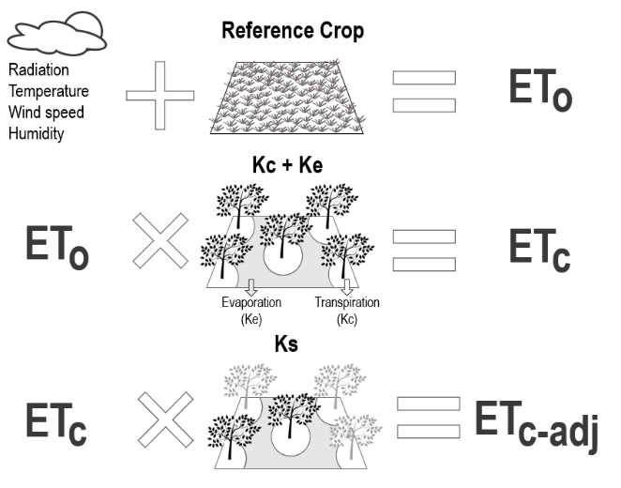

Although, the crop evapotranspiration may vary regarding water stress situations, since once the crop reached a threshold (i.e., critical point) the amount of water losses by way of transpiration starts becoming lower. The Readily Available Water (RAW) is the amount of water a specific crop can extract from the root zone just before start suffering water stress. It is a function of TAW regarding the average proportion of water can be depleted before moisture stress – $cd$ [0-1] (equation [6]):

|  |  |
| --- | --- |
|  | [] |

where:

|  |  |
| --- | --- |
|  | [] |

being the average water depletion fraction for no water stress periods. Therefore, if the water content is over RAW, there is a depletion rate by transpiration according to equation [5], on the contrary, if the water it’s been depleted over RAW, there is a reduced depletion rate according to:

|  |  |
| --- | --- |
|  | [] |

where represents the water stress coefficient and it’s determined by equation [9], where $D_{r,i}$ represents the water root zone depletion $\left[mm\right]$. The $k_{s}$ has a behavior showed in the figure

|  |  |
| --- | --- |
|  | [] |

Figure B3: Water stress coefficient. Adapted from (Allen et al., 2006).

Water stress coefficient. Adapted from (Allen et al., 2006).

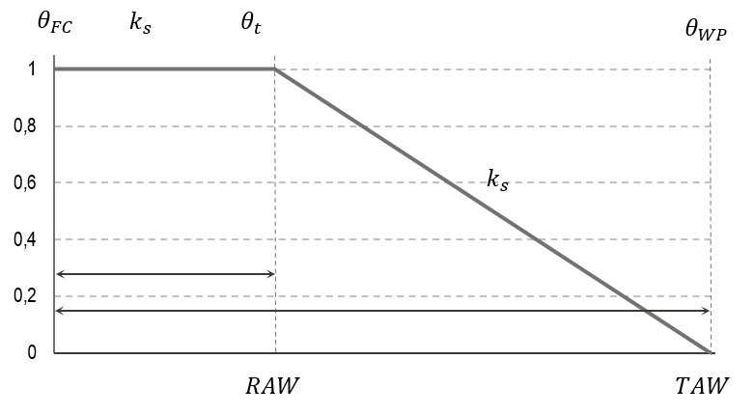

* + 1. **Water root zone depletion - $D_{r,i}$ $(mm)$**

It represents the daily water balance between inflow and outflow parameters, relating the amount of water loss by the crop every day in the root zone, and allows obtaining the amount of water left in the root zone through the following equation:

|  |  |
| --- | --- |
|  | [] |

where:

* is the root depletion at the end $i_{th}$ day $[mm]$.
* $D_{r,i-1}$ represents the water content in the root zone in the previous day $[mm]$
* $P_{i}$ is the daily precipitation $[mm]$.
* $RO_{i}$ represents the runoff from the soil surface on the $i_{th}$ day $[mm]$
* $I_{i}$ is the net irrigation $[mm]$.
* $CR_{i}$ represents the water content transported upwards by capillary rise on the $i_{th}$ day $[mm]$.
* $ET_{c,i}$ is the crop evapotranspiration on the $i_{th}$ day $[mm]$.
* $DP_{i}$ the water loss of the root zone by deep percolation on the $i_{th}$ day $[mm]$.

Then, it is important to note that the amount of water depleted never can be higher than the amount of water storage in the root zone:

|  |  |
| --- | --- |
|  | [] |

And is also related to the Plant Available Water ($PAW$) since:

|  |  |
| --- | --- |
|  | [] |

* + 1. **Crop characteristics**

The crop characteristics represents specific crop properties that affects the inflow and outflow parameters.

* 1. **Stages ($days$)**

It corresponds to the initial, development, mid-season, and last-season crop production stages relating the fruit (or pod) development.

* 1. **Rooting depth ($m$)**

It refers to the crop root depth.

* 1. **Yield response factor - $k_{y}$**

It represents the factor related to the yield reduction considering an evapotranspiration reduction. See the Appendix C to follow the strategy used for the parameter calculation.

* 1. **Crop height ()**

It is the actual crop height.

* + 1. **Soil characteristics**
  1. **Maximum rain infiltration rate ($mm/day$)**

It refers to the maximum amount of water that enters the soil per time. It depends on the soil type considering that every soil allows different amounts of water infiltration. The textural triangle supported by the United States Department of Agriculture allows determining the soil type according to the percent of clay, silt, and sand the land possesses.

Figure B4: Textural triangle. Retrieved from Soil Science Division Staff (2017).

Textural triangle. Retrieved from Soil Science Division Staff (2017).

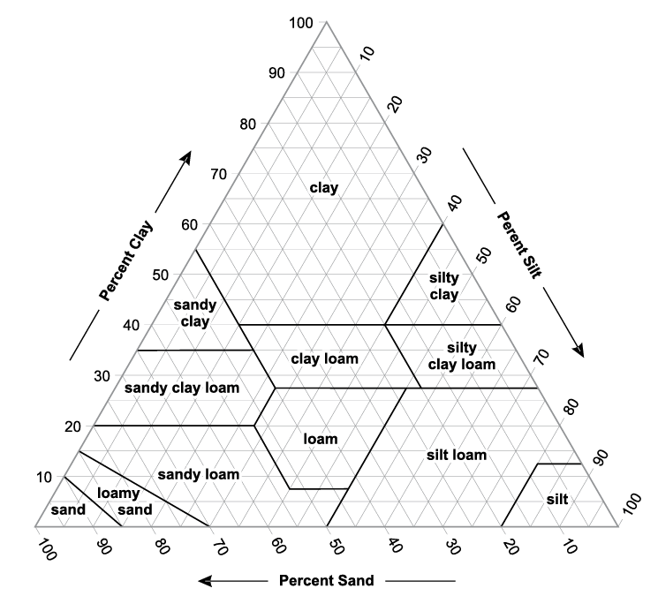

* 1. **Maximum rooting depth ($cm$)**

It refers to the crop's maximum rooting depth.

**Parameters related to the water content in the root zone**

Table B1: Water content parameters

Crop water balance parameters

|  |  |  |  |  |
| --- | --- | --- | --- | --- |
| Component | Input Parameters | Unit | Independent Parameter | Source |
| Water content | Irrigation | $$mm/day$$ | - | Decision-maker control |
| Precipitation | $$mm/day$$ | - | (NASA, 2021) |
| Capillary rise | $$mm/day$$ | - | Negligible (Allen et al., 2006) |
| Deep percolation | $$mm/day$$ | - | Negligible |
| Runoff | $$mm/day$$ | - | Negligible |
| $$ET_{c}$$ | $$mm/day$$ | Minimum temperature - $T_{min}$ ($°C$) | (NASA, 2021) |
| Maximum temperature - $T_{max}$ ($°C$) | (NASA, 2021) |
| Humidity - $H$ (%) | (NASA, 2021) |
| Wind speed - $u_{2}$ ( $m/s)$ | (NASA, 2021) |
| Radiation - $R_{n}$ ( $MJ/m^{2}day$*)* | (NASA, 2021) |
| Crop coefficient - $k_{c}$ | (Allen et al., 2006) and (Naranjo-Merino et al., 2017) |
| $$ET_{c,adj}$$ | $$mm/day$$ | Critical depletion - $cd$ (%) | (Allen et al., 2006) and (Naranjo-Merino et al., 2017) |
| Crop | Stages | $$days$$ | - | (Allen et al., 2006) and (Ten Hoopen et al., 2012) |
| Rooting depth | $$cm$$ | - | (Allen et al., 2006) and (Naranjo-Merino et al., 2017) |
| Yield Response Factor - $k_{y}$ | $$-$$ | The actual crop yield - $Y_{a}$ (kg/ha) | Through SIMPLE model |
| The maximum yield - $Y_{m}$ (kg/ha) |
| The actual crop evapotranspiration - $ET_{a}$ ( $mm/day)$ | Estimated |
| The maximum crop evapotranspiration - $ET_{m}$ ( $mm/day)$ |
| Crop height | $$m$$ | - | (Allen et al., 2006) |
| Soil | Total available water - $TAW$ | $$mm/m$$ | The soil type | (León-Moreno et al., 2019) and (Soil Science Division Staff, 2017) |
| The water content at field capacity - $θ_{FC}$ ($m^{3}/m^{3}$) | (Saxton & Rawls, 2006) |
| The water content at wilting point - $θ_{WP}$ ($m^{3}/m^{3}$) | (Saxton & Rawls, 2006) |
| Maximum rain infiltration rate | $$mm/day$$ | - | (Hillel, 2003) and (Minnesota Stormwater Committee, 2008) |
| Maximum rooting depth | $$cm$$ | - | (Allen et al., 2006) |
| Initial soil moisture depletion | $$\%$$ | Total available water - $TAW$ | (Allen et al., 2006) |